3_2: **DESIGN AND ANALYSIS OF ALGORITHMS**

**UNIT-1:** **Algorithm Analysis, Divide and Conquer**

**INTRODUCTION**: Algorithm Definition, Algorithm Specification, Performance Analysis, Performance Measurement, Asymptotic notations.   
**DIVIDE AND CONQUER**: General Method, Binary Search, Finding the Maximum and Minimum, Quick Sort.  
  
Unit 1 covers foundational concepts in algorithm design and analysis. It introduces the core principles of algorithms, their efficient design, and evaluation. Understanding these topics is crucial for developing efficient algorithms, solving problems, and optimizing computational tasks. **Introduction:**

1. Algorithm Definition: Algorithms are step-by-step procedures or sets of instructions designed to solve problems or perform tasks in computer science. They involve inputs, outputs, and a sequence of actions.
2. Algorithm Specification: The precise and clear description of algorithms that includes inputs, outputs, steps, termination conditions, control structures, and data structures used.
3. Performance Analysis: Involves examining an algorithm's efficiency in terms of time and space complexity.
4. Performance Measurement: Includes analyzing the steps and operations executed by an algorithm (step count) and how frequently certain operations occur (frequency count).
5. Asymptotic Notations: Mathematical notations like Big O, Big Omega, and Big Theta used to describe an algorithm's behavior concerning its time or space complexity as the input size grows.

**Divide and Conquer:**

1. General Method: A problem-solving technique that breaks down a problem into smaller, more manageable subproblems, solves them recursively, and combines their solutions to solve the main problem.
2. Binary Search: An efficient search algorithm used on sorted arrays by repeatedly dividing the search interval in half and narrowing down the possible locations of the target value.
3. Finding the Maximum and Minimum: Techniques for efficiently finding the maximum and minimum values in an array, usually involving iterations through the array while keeping track of the maximum and minimum values encountered.
4. Quick Sort: A sorting algorithm that uses a divide-and-conquer strategy by selecting a pivot element and partitioning the array into smaller subarrays based on the pivot, sorting them recursively.

**What is Algorithm?**

A finite set of instruction that specifies a sequence of operation is to be carried out in order to solve a specific problem or class of problems is called an Algorithm.

**Why study Algorithm?**

As the speed of processor increases, performance is frequently said to be less central than other software quality characteristics (e.g. security, extensibility, reusability etc.). However, large problem sizes are commonplace in the area of computational science, which makes performance a very important factor. This is because longer computation time, to name a few mean slower results, less through research and higher cost of computation (if buying CPU Hours from an external party). The study of Algorithm, therefore, gives us a language to express performance as a function of problem size.  
  
**Key Elements of an Algorithm:**

* **Inputs:** Algorithms start with one or more inputs, which are the initial data or values upon which the algorithm operates.
* **Outputs**: These are the results or solutions produced by the algorithm after processing the inputs.
* **Steps/Instructions:** Algorithms consist of a finite number of steps or instructions, each describing a specific action or operation to be performed on the input data.
* **Termination:** A well-defined algorithm eventually terminates, producing the desired output(s) after a finite number of steps.  
  **Examples:**

Example 1: Finding the Maximum Number in an Array

**Algorithm Steps:**

**1.Start.**

Set the maximum number as the first element of the array.

**2.Traverse through the array:**

Compare each element with the current maximum number.

If the element is greater than the current maximum, update the maximum.

Repeat step 3 until all elements are checked.

The maximum number found is the output.

**3.Stop**.

Visual Representation:

**Here's a simple visualization to illustrate the algorithm:**

**Algorithm:** Find Maximum Number in Array

**Input:** Array of integers

**Output:** Maximum number in the array

1. Start

2. Set max = arr[0] (first element of the array)

3. For each element x in the array:

*If x > max, set max = x*

4. Output max as the maximum number

5. Stop

**Example 2: Sorting Algorithm - Bubble Sort**

Bubble Sort is a simple sorting algorithm that repeatedly steps through the list, compares adjacent elements, and swaps them if they are in the wrong order.

**Algorithm Steps:**

* Start.
* Traverse through the list.
* Compare adjacent elements.
* Swap them if they are in the wrong order.
* Repeat steps 2-4 until no swaps are needed.
* Stop.
* Visual Representation:

A visual representation or animation demonstrating the Bubble Sort algorithm would involve showing the elements swapping positions until the list is sorted.  
**______________________**____________________________________________________________________________

**Algorithm Specification:**

Algorithm specification is the process of clearly defining the steps, input, output, and limitations of an algorithm. It is a crucial step in algorithm design, as it ensures that the algorithm is well-understood and can be implemented correctly.

**Components of Algorithm Specification**

A complete algorithm specification typically includes the following components:

* **Problem Statement:** Clearly define the problem that the algorithm is intended to solve.
* **Input:** Specify the data or information that the algorithm needs to function.
* **Output:** Describe the expected results or outcomes produced by the algorithm.
* **Algorithm Steps:** Provide a detailed description of the sequence of steps taken by the algorithm to solve the problem.
* **Limitations**: Clearly identify any restrictions or assumptions associated with the algorithm's applicability.

**Benefits of Algorithm Specification**

Algorithm specification offers several benefits, including:

**Clarity and Understanding:** A well-defined specification ensures that everyone involved in the algorithm's development and implementation has a clear understanding of its purpose, operation, and limitations.

**Implementation Guidance:** A detailed specification serves as a roadmap for implementing the algorithm in a programming language or other form of execution.

**Error Prevention**: Careful specification helps identify potential errors and inconsistencies in the algorithm's design early on, reducing the risk of defects in the implementation.

**Communication and Collaboration:** A clear specification facilitates communication and collaboration among team members working on different aspects of the algorithm's development and application.

**Documentation and Maintenance:** A comprehensive specification serves as valuable documentation for future reference and maintenance purposes.

**Example of Algorithm Specification**

Consider the algorithm for finding the maximum value in an array of numbers:

**Problem Statement:** Find the largest number in a given array of numbers.

**Input:** An array of numbers (A)

**Output**: The maximum value in the array (max)

**Algorithm** **Steps**:

Initialize a variable max to store the maximum value.

Set max to the first element in the array.

Iterate through the remaining elements of the array.

For each element, compare it to the current value of max.

If the current element is greater than max, update max to the current element.

Return the value of max.

**Limitations:** The algorithm assumes that the input array contains at least one element.  
__________________________________________________________________________________________________

**Performance Analysis - Time and Space Complexity:**

**Time Complexity:**

**Definition**: Time complexity refers to the estimation of the amount of time an algorithm takes to complete its execution concerning the input size. It quantifies the number of operations or steps an algorithm requires to solve a problem.

**Common Big O notations include:**

* O(1): Constant time complexity – The algorithm's execution time remains constant regardless of the input size.
* O(log n): Logarithmic time complexity – The algorithm's execution time grows logarithmically with the input size.
* O(n): Linear time complexity – The algorithm's execution time increases linearly with the input size.
* O(n^2): Quadratic time complexity – The algorithm's execution time increases quadratically with the input size.
* O(2^n): Exponential time complexity – The algorithm's execution time increases exponentially with the input size.

**Space Complexity:**

**Definition:** Space complexity is the measure of the amount of memory space an algorithm needs concerning the input size. It estimates the total memory space required by an algorithm throughout its execution.

Space complexity is also typically expressed using Big O notation.

Common Big O notations for space complexity include:

* O(1): Constant space complexity – The algorithm's memory usage remains constant regardless of the input size.
* O(log n): Logarithmic space complexity – The algorithm's memory usage grows logarithmically with the input size.
* O(n): Linear space complexity – The algorithm's memory usage increases linearly with the input size.
* O(n^2): Quadratic space complexity – The algorithm's memory usage increases quadratically with the input size.

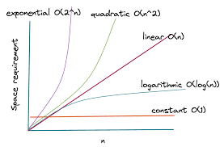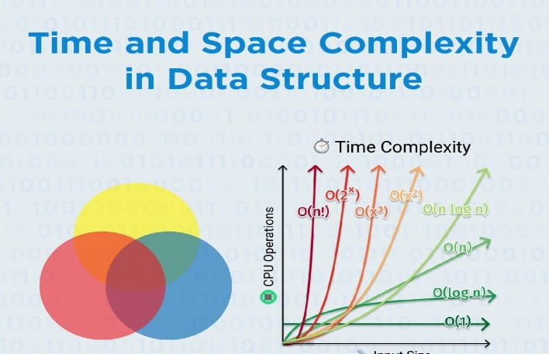

**Example: Linear Search**

Linear search is a simple algorithm for finding a specific element in an unsorted array. It iterates through the array, comparing each element to the target element, until it either finds the target or reaches the end of the array.

Python

*def linear_search(array, target):*

*for element in array:*

*if element == target:*

*return True*

*return False*

The time complexity of linear search is O(n), where n is the length of the array. This means that the execution time of linear search grows linearly with the size of the input array. The space complexity of linear search is also O(1), as it only requires constant memory for temporary variables.

**Example: Binary Search**

Binary search is a more efficient algorithm for finding a specific element in a sorted array. It repeatedly divides the array in half, narrowing down the search range until it finds the target element or determines that the target element is not in the array.

Python

*Def binary_search(array, target):*

*low = 0*

*high = len(array) - 1*

*while low <= high:*

*mid = (low + high) // 2*

*if array[mid] == target:*

*return mid*

*elif array[mid] < target:*

*low = mid + 1*

*else:*

*high = mid – 1*

*return -1*

The time complexity of binary search is O(log n), where n is the length of the sorted array. This means that the execution time of binary search grows logarithmically with the size of the input array. The space complexity of binary search is also O(log n), as it requires additional memory for the recursion stack.

**Performance Measurement - Step Count and Frequency Count:**

**Step Count:**

Definition: Step count involves determining the number of basic operations or steps executed by an algorithm to perform a specific task. These steps can include assignments, comparisons, arithmetic operations, etc.

Importance: Measuring the step count helps in evaluating an algorithm's efficiency and understanding how its execution time may vary concerning different input sizes.

Example:

Consider a simple algorithm to sum the elements of an array:

python

*def sum_array(arr):*

*total = 0*

*for num in arr:*

*total += num*

*return total*

Step Count Analysis**:** In this algorithm, each addition operation (total += num) inside the loop contributes to the step count. For an array of size n, the step count would be approximately 2n + 2, considering the initial assignment and loop setup.

**Frequency Count:**

Definition: Frequency count involves determining how often certain operations occur or how frequently certain instructions are executed within an algorithm.

Importance: Understanding frequency count helps identify the most frequently executed parts of an algorithm, which can be crucial in optimizing algorithms for efficiency.

**Example:**

Consider a search algorithm for finding a specific element in an array:

Python

*def search_element(arr, target):*

*for num in arr:*

*if num == target:*

*return True*

*return False*

Frequency Count Analysis: In this algorithm, the comparison operation if num == target occurs for each element in the array. Therefore, its frequency count is n, where n is the size of the array.

**Asymptotic Notations - Big O, Big Omega, Big Theta:**Asymptotic Notations:

Asymptotic notations are a set of mathematical notations used to describe the upper and lower bounds of the growth rate of a function as the input size increases. These notations are particularly useful in computer science for analyzing the performance of algorithms and data structures.

**1.**Big O Notation (O)

Big O notation represents the upper bound of the growth rate of a function. It describes the worst-case scenario in terms of how the function's execution time or memory usage increases as the input size grows. Big O notation is written as O(f(n)), where f(n) is a function of the input size n.

Examples of Big O Notation:

* O(1): Constant time complexity: The function's execution time or memory usage remains constant regardless of the input size.
* O(log n): Logarithmic time complexity: The function's execution time or memory usage grows logarithmically with the input size.
* O(n): Linear time complexity: The function's execution time or memory usage increases linearly with the input size.
* O(n^2): Quadratic time complexity: The function's execution time or memory usage increases quadratically with the input size.
* O(2^n): Exponential time complexity: The function's execution time or memory usage increases exponentially with the input size.

**2.**Big Omega Notation (Ω)

Big Omega notation represents the lower bound of the growth rate of a function. It describes the best-case scenario in terms of how the function's execution time or memory usage increases as the input size grows. Big Omega notation is written as Ω(f(n)), where f(n) is a function of the input size n.

Examples of Big Omega Notation:

* Ω(1): Constant time complexity: The function's execution time or memory usage is always at least constant, even in the best-case scenario.
* Ω(log n): Logarithmic time complexity: The function's execution time or memory usage is at least logarithmic in the best-case scenario.
* Ω(n): Linear time complexity: The function's execution time or memory usage is at least linear in the best-case scenario.
* Ω(n^2): Quadratic time complexity: The function's execution time or memory usage is at least quadratic in the best-case scenario.
* Ω(2^n): Exponential time complexity: The function's execution time or memory usage is at least exponential in the best-case scenario.

**3.**Big Theta Notation (Θ)

Big Theta notation represents the tightest possible bound of the growth rate of a function. It describes both the upper and lower bounds of the function's execution time or memory usage as the input size grows. Big Theta notation is written as Θ(f(n)), where f(n) is a function of the input size n.

Examples of Big Theta Notation:

* Θ(1): Constant time complexity: The function's execution time or memory usage is always constant, both in the best-case and worst-case scenarios.
* Θ(log n): Logarithmic time complexity: The function's execution time or memory usage is both logarithmic in the best-case scenario and logarithmic in the worst-case scenario.
* Θ(n): Linear time complexity: The function's execution time or memory usage is both linear in the best-case scenario and linear in the worst-case scenario.
* Θ(n^2): Quadratic time complexity: The function's execution time or memory usage is both quadratic in the best-case scenario and quadratic in the worst-case scenario.
* Θ(2^n): Exponential time complexity: The function's execution time or memory usage is both exponential in the best-case scenario and exponential in the worst-case scenario.

**Relationship between Big O, Big Omega, and Big Theta**

* Big O ≥ Big Omega: The upper bound (Big O) must be greater than or equal to the lower bound (Big Omega).
* Big Theta = Big O ∩ Big Omega: If a function's growth rate is tightly bound by both Big O and Big Omega, then it falls under Big Theta notation.

**Applications of Asymptotic Notations**

Asymptotic notations are widely used in computer science for various purposes, including:

* **Algorithm Analysis:** Analyzing the time and space complexity of algorithms to determine their efficiency and scalability.
* **Data Structure Analysis:** Evaluating the performance of data structures in terms of their access, insertion, and deletion times.
* **System Design:** Making informed decisions about resource allocation and optimization in system design.

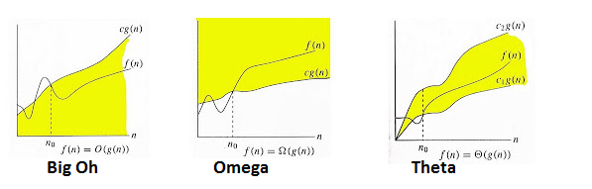

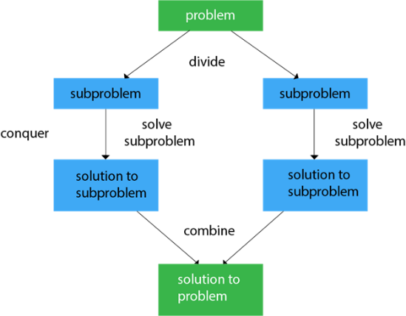**Divide and Conquer**   
**General Method:** The divide-and-conquer algorithm is a powerful algorithmic technique that breaks down a problem into smaller subproblems, solves the subproblems recursively, and then combines the solutions to the subproblems to solve the original problem. This approach is particularly effective for solving problems that can be naturally divided into smaller, independent subproblems.

The General Method of Divide and Conquer typically consists of three fundamental steps:

* **Divide:** Break the problem into smaller, more easily solvable subproblems. This step involves dividing the problem into multiple parts or instances.
* **Conquer:** Solve these smaller subproblems independently. Apply the same approach recursively to solve each subproblem until they become simple enough to solve directly.
* **Combine:** Merge or combine the solutions of the subproblems to obtain the final solution to the original problem.

Example:

Let's consider the problem of finding the maximum element in an array using the Divide and Conquer approach:

Algorithm Steps:

* Divide: Divide the array into two halves.
* Conquer: Recursively find the maximum element in each half.
* Combine: Compare the maximum elements found in the two halves and return the larger one as the final maximum.  
  Characteristics of Divide-and-Conquer Algorithms

**Divide-and-conquer algorithms typically exhibit the following characteristics:**

1. Recursiveness: The algorithm calls itself recursively to solve the smaller subproblems.
2. Base Cases: The algorithm has base cases, which are trivial subproblems that can be solved directly without further recursion.
3. Combining Solutions: The algorithm combines the solutions to the subproblems to obtain the solution to the original problem.

**Advantages of Divide-and-Conquer Algorithms**

Divide-and-conquer algorithms offer several advantages, including:

1. Efficiency: Divide-and-conquer algorithms can often solve problems more efficiently than other approaches, especially for large problems.
2. Scalability: Divide-and-conquer algorithms can handle large problems well, as they can be easily divided into smaller subproblems.
3. *Simplicity:* Divide-and-conquer algorithms are often conceptually simple and easy to understand.

**Examples of Divide-and-Conquer Algorithms:**

Numerous algorithms fall under the category of divide-and-conquer algorithms. Some well-known examples include:

* **Merge Sort:** A sorting algorithm that divides the unsorted list into halves, recursively sorts the halves, and then merges the sorted halves to obtain the sorted list.
* **Quick Sort:** A sorting algorithm that partitions the unsorted list around a pivot element, recursively sorts the sub-lists on either side of the pivot, and finally combines the sorted sub-lists.
* **Binary Search:** A search algorithm that repeatedly divides the sorted array in half until the target element is found or it is determined that the target element is not in the array.
* **Strassen's Algorithm:** A matrix multiplication algorithm that divides the matrices into submatrices, recursively multiplies the submatrices, and then combines the results to obtain the final matrix product.

**Binary Search using Divide and Conquer:**Procedure**:**

1. Initialization: Begin with a sorted array.
2. Define Boundaries: Set the lower and upper boundaries of the search interval (initially, the entire sorted array).
3. Middle Element: Calculate the middle element of the current interval.
4. Compare target value: Compare the target value to the element at the mid index.

a. Target value found: If the target value equals the element at mid, the target value has been found, and the search is complete.

b. Target value in lower half: If the target value is less than the element at mid, the target value must be in the lower half of the array. Update high to mid - 1.

c. Target value in upper half: If the target value is greater than the element at mid, the target value must be in the upper half of the array. Update low to mid + 1.

1. Repeat: Recursively perform steps 3-4 on the narrowed interval until the target is found or the interval becomes empty.

**Example -1**:

Consider an array [2, 4, 6, 8, 10, 12, 14, 16, 18, 20] and a target value of 12.

**Algorithm Execution:**

Initial search interval: [2, 4, 6, 8, 10, 12, 14, 16, 18, 20]

Middle element: 10 (at index 4)

Compare: 10 < 12 (target value)

Adjust boundaries: New interval becomes [12, 14, 16, 18, 20]

Middle element: 14 (at index 6)

Compare: 14 > 12 (target value)

Adjust boundaries: New interval becomes [12]

Target found at index 5.  
**Example -2**:

Consider a sorted array: [2, 5, 8, 12, 16, 23, 38, 56, 72, 91]. The goal is to find the index of the target value 23.

Python:

*low = 0*

*high = len(array) - 1*

*while low <= high:*

*mid = (low + high) // 2*

*if array[mid] == 23:*

*print("The index of 23 is", mid)*

*break*

*elif array[mid] < 23:*

*low = mid + 1*

*else:*

*high = mid - 1*

**Algorithm:**

python

*def binary_search(arr, target, low, high):*

*if high >= low:*

*mid = (low + high) // 2*

*if arr[mid] == target:*

*return mid*

*elif arr[mid] > target:*

*return binary_search(arr, target, low, mid - 1)*

*else:*

*return binary_search(arr, target, mid + 1, high)*

*else:*

*return -1 # Target not found*

**Computing Time Complexity:**

The binary search algorithm exhibits a time complexity of O(log n), where n represents the number of elements in the sorted array. This implies that the number of operations required to locate the target value grows logarithmically with the array's size. This makes binary search significantly more efficient than linear search, which has a time complexity of O(n).

**Applications:**

Binary search finds applications in a wide range of scenarios, including:

* Searching for data in databases: Binary search efficiently locates specific records within large databases
* Finding the root of an equation: Binary search can be employed to determine the root of an equation by repeatedly narrowing down the search interval.
* Sorting data: Binary search is used in various sorting algorithms, such as merge sort, to efficiently merge sorted subarrays.
* Finding the median of a list of numbers: Binary search can effectively determine the median value in a sorted list of numbers.

**Finding the Maximum and Minimum**

The Divide-and-Conquer approach can be effectively utilized to find both the maximum and minimum elements within an array. The algorithm recursively divides the array into smaller subarrays until it reaches the base case, where the maximum and minimum can be easily determined.

**Procedure**

The Divide-and-Conquer algorithm for finding the maximum and minimum follows these steps:

* Divide: Recursively divide the array into two halves until each subarray contains only a single element.
* Conquer: For each subarray of size 1, the maximum and minimum values are trivially determined.
* Combine: At each level of the recursion tree, compare the maximum and minimum values from the two child subarrays to find the overall maximum and minimum values for the current subarray.
* Base Case: The base case occurs when a subarray contains only one element. The maximum and minimum are both equal to that single element.

**Example**

Consider an unsorted array: [5, 3, 1, 7, 6, 2, 4]. The goal is to find both the maximum and minimum values in this array.

Python

*def find_max_min(array, low, high):*

*if low == high:*

*return array[low], array[low]* 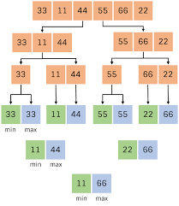

*mid = (low + high) // 2*

*left_max, left_min = find_max_min(array, low, mid)*

*right_max, right_min = find_max_min(array, mid + 1, high)*

*return max(left_max, right_max), min(left_min, right_min)*

*max_value, min_value = find_max_min(array, 0, len(array) - 1)*

*print("Maximum:", max_value)*

*print("Minimum:", min_value)*

**Algorithm**

Python

*def find_max_min(array, low, high):*

*if low == high:*

*return array[low], array[low]*

*mid = (low + high) // 2*

*left_max, left_min = find_max_min(array, low, mid)*

*right_max, right_min = find_max_min(array, mid + 1, high)*

*return max(left_max, right_max), min(left_min, right_min)*

**(or)**

**Algorithm: Max-Min-Element (numbers[])**

max := numbers[1]

min := numbers[1]

for i = 2 to n do

if numbers[i] > max then

max := numbers[i]

if numbers[i] < min then

min := numbers[i]

return (max, min)

**Computing Time Complexity**

The Divide-and-Conquer algorithm for finding the maximum and minimum exhibits a time complexity of O(n log n), where n represents the number of elements in the array. This implies that the number of operations required to find the maximum and minimum grows logarithmically with the array's size. This makes the Divide-and-Conquer approach significantly more efficient than linear search, which has a time complexity of O(n).

**Applications**

The Divide-and-Conquer algorithm for finding the maximum and minimum finds applications in a variety of scenarios, including:

* Data analysis: Identifying the minimum and maximum values within a dataset is crucial for understanding the range of data values.
* Performance optimization: Determining the maximum and minimum response times of an algorithm can help optimize its performance.
* Resource allocation: Finding the maximum and minimum resource utilization can aid in efficient resource allocation and management.
* Error detection: Identifying outliers or abnormal values by comparing them to the maximum and minimum can help detect errors or anomalies in data.

**Quick Sort using Divide and Conquer:**  
Quick sort is a divide-and-conquer algorithm that efficiently sorts an array of elements. It works by recursively partitioning the array into smaller subarrays until they are trivially sorted, and then merging the sorted subarrays back together.

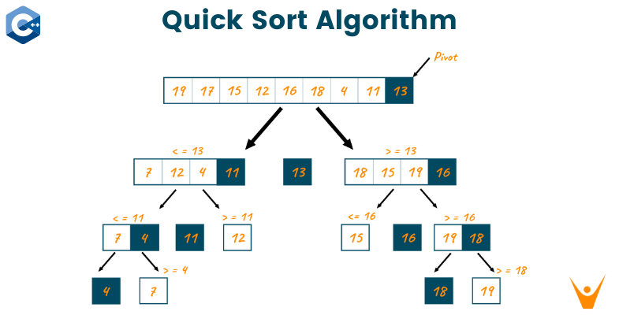**Procedure:**

* Divide: Select a pivot element from the array.
* Partitioning: Rearrange the elements in the array so that elements smaller than the pivot are placed before it, and elements greater than the pivot are placed after it.
* Recursively Sort Subarrays: Apply Quick Sort recursively to the subarrays formed by the partitioning process.
* Combine: No specific combine step as the array is sorted in place during the partitioning and recursive sorting.

**Example:**

Consider sorting the array [9, 7, 5, 11, 12, 2, 14, 3, 10, 6].

* Partition: Choose the pivot element as 6. Rearrange the array: [5, 2, 3, 6, 12, 11, 14, 9, 10, 7].
* Recursively Sort: Recursively sort the subarrays [5, 2, 3] and [12, 11, 14, 9, 10, 7].
* Merge: Merge the sorted subarrays: [2, 3, 5, 6, 7, 9, 10, 11, 12, 14].

**Algorithm Execution:**

Select a pivot element (e.g., the last element: 4).

Partition the array:

[2, 1, 3] (Elements smaller than the pivot 4)

[6, 8, 5, 7] (Elements greater than the pivot 4)

Recursively apply Quick Sort to the subarrays:

[1, 2, 3]

[5, 6, 7, 8]

Combine the sorted subarrays: [1, 2, 3, 4, 5, 6, 7, 8] (Fully sorted array)

**Algorithm:**

Python:

*def quick_sort(arr):*

*if len(arr) <= 1:*

*return arr*

*else:*

*pivot = arr[-1]*

*lesser = [x for x in arr[:-1] if x <= pivot]*

*greater = [x for x in arr[:-1] if x > pivot]*

*return quick_sort(lesser) + [pivot] + quick_sort(greater)*

**Time Complexity:**

The average-case time complexity of Quick Sort using Divide and Conquer is O(n log n), where 'n' is the number of elements in the array. However, in the worst-case scenario (when the pivot is the smallest or largest element), the time complexity can degrade to O(n^2). Nevertheless, Quick Sort is widely regarded as highly efficient for sorting large datasets due to its average-case performance.

**Computing Time Complexity:**

Best Case: O(n log n)

Average Case: O(n log n)

Worst Case: O(n^2)

**Applications:**

* Database Management Systems: Quicksort is widely used in database management systems (DBMS) for sorting large datasets of records, such as employee information, customer data, or product inventory. It efficiently organizes data for efficient retrieval and analysis.
* Information Retrieval: Quicksort plays a crucial role in information retrieval systems, where it is employed for ranking search results based on relevance or importance. It helps organize and prioritize search results to provide users with the most relevant information.
* Numerical Computing: Quicksort is extensively used in numerical computing applications, such as scientific computing and machine learning, for sorting large arrays of numerical data. It facilitates efficient analysis and manipulation of numerical data.
* Web Development: Quicksort finds applications in web development, particularly in web frameworks like Flask and Django. It enables efficient sorting of data in web applications, such as routing, URL building, and data manipulation.
* Cryptography: Quicksort is employed in cryptography algorithms to sort cryptographic keys and data structures, ensuring secure and efficient data processing.
* Operating Systems: Quicksort is used in operating systems for tasks such as managing memory allocation, handling file system operations, and scheduling tasks. It contributes to efficient resource management and system performance.
* Scientific Applications: Quicksort is utilized in scientific simulations, data analysis, and scientific visualization to organize and process large volumes of scientific data. It enhances the efficiency and accuracy of scientific calculations.

**UNIT-2: THE GREEDY METHOD**

**UNIT-II: THE GREEDY METHOD:** The General Method, Knapsack Problem, Single Source Shortest Path Problem, Optimal Storage on Tapes Problem, Optimal Merge Patterns Problem.

* The greedy method is a simple and intuitive algorithm design paradigm that aims to find a solution by making the most locally optimal choice at each step.
* It follows a heuristic approach, meaning it focuses on making the best decision in the present without considering the broader implications of this choice for the overall solution.
* The general approach of the greedy method involves identifying the objective, breaking down the problem, making locally optimal choices, and repeating these steps until the solution is complete.
* Key characteristics of the greedy method include local optimality, ease of implementation, heuristic approach, and effectiveness for certain types of problems.
* Examples of greedy algorithms include Dijkstra's Algorithm, Huffman Coding, and Activity Selection Problem.
* Limitations of the greedy method include suboptimality, overlooking long-term consequences, and requiring careful choice of heuristic.
* Applications of greedy algorithms include resource allocation, scheduling tasks, data compression, and problem-solving in various domains.

In summary, the greedy method is a useful tool for solving optimization problems, but it's important to recognize its limitations and carefully evaluate its suitability for the specific problem at hand.

**General Method:**

* The greedy method is a straightforward algorithmic approach that involves making the best decision at each step, without considering the overall outcome. It is often used to solve optimization problems, where the goal is to find the best solution given a set of constraints.”””
* The Greedy method is the simplest and straightforward approach. It is not an algorithm, but it is a technique. The main function of this approach is that the decision is taken on the basis of the currently available information. Whatever the current information is present, the decision is made without worrying about the effect of the current decision in future.
* This technique is basically used to determine the feasible solution that may or may not be optimal. The feasible solution is a subset that satisfies the given criteria. The optimal solution is the solution which is the best and the most favourable solution in the subset. In the case of feasible, if more than one solution satisfies the given criteria then those solutions will be considered as the feasible, whereas the optimal solution is the best solution among all the solutions.

**Key Points of the Greedy Method:**

* Iterative Approach: The greedy method constructs a solution step by step, making locally optimal choices at each stage.
* Decision Irreversibility: Once a decision is made, it cannot be undone, leading to potential sub-optimality.
* Myopic Perspective: The greedy method focuses on immediate gains, without considering long-term consequences.

**General Method of the Greedy Algorithm:**

* Objective Identification:

*Purpose*: Define the goal or objective to optimize in the problem.

*Example*: In a scheduling problem, the objective might be to maximize the number of tasks completed.

* Breaking Down the Problem:

*Segmentation*: Divide the problem into smaller, manageable parts or stages.

*Illustration*: Splitting a problem into tasks or components for easier processing.

* Making Locally Optimal Choices:

*Immediate Best Decision*: Select the most beneficial option at each step.

*Visualization:* Choosing the next step based on the current best option without considering future implications.

* Repetition until Solution:

*Iterative Process:* Repeating steps 2 and 3 until the solution is reached.

*Example Scenario:* In a scheduling problem, iterating through available tasks and selecting the next one based on the immediate best choice.

**Characteristics of Greedy method**

The following are the characteristics of a greedy method:

* Local optimality: Focuses on making the best choice at each step without considering the broader context.
* Easy to implement: Simple and straightforward to apply, making it understandable and efficient.
* Heuristic approach: Relies on rules of thumb rather than an exhaustive search, leading to potential suboptimal solutions.
* Effective for certain types of problems: Works well for problems that have specific properties and constraints.
* To construct the solution in an optimal way, this algorithm creates two sets where one set contains all the chosen items, and another set contains the rejected items.
* A Greedy algorithm makes good local choices in the hope that the solution should be either feasible or optimal.

**Components of Greedy Algorithm**

***The components that can be used in the greedy algorithm are:***

* Candidate set: A solution that is created from the set is known as a candidate set.
* Selection function: This function is used to choose the candidate or subset which can be added in the solution.
* Feasibility function: A function that is used to determine whether the candidate or subset can be used to contribute to the solution or not.
* Objective function: A function is used to assign the value to the solution or the partial solution.
* Solution function: This function is used to intimate whether the complete function has been reached or not.

**The Greedy Method can be described in three phases:**

1. **Greedy Selection**: In this phase, the algorithm selects the best option available at each step based on a certain condition. It is like taking the "best deal" at each step without looking ahead.
2. **Implementation**: After selecting the best option, the algorithm implements the chosen solution and updates the system or data structure accordingly.
3. **Termination**: The algorithm continues to run until a termination condition is met, such as finding the maximum or minimum solution value.

**Pseudo code of Greedy Algorithm:**

*Algorithm Greedy (a, n)*

*{*

*Solution : = 0;*

*for i = 0 to n do*

*{*

*x: = select(a);*

*if feasible(solution, x)*

*{*

*Solution: = union(solution , x)*

*}*

*return solution;*

*} }*

**Applications of Greedy Algorithm**

1. Resource allocation: Allocating limited resources to multiple tasks or processes.
2. Scheduling tasks: Efficiently scheduling tasks or activities to optimize resource utilization.
3. Data compression*:* Compressing data to reduce storage requirements or transmission time.
4. Problem-solving in various domains: Solving optimization problems in various fields, such as network design, scheduling, and resource allocation.
5. It is used in finding the shortest path.
6. It is used to find the minimum spanning tree using the prim's algorithm or the Kruskal's algorithm.
7. It is used in a job sequencing with a deadline.
8. This algorithm is also used to solve the fractional knapsack problem.

**Disadvantages of using Greedy algorithm**

* Greedy algorithm makes decisions based on the information available at each phase without considering the broader problem. So, there might be a possibility that the greedy solution does not give the best solution for every problem.
* It follows the local optimum choice at each stage with a intend of finding the global optimum. Let's understand through an example.
* Suboptimality: May not find the globally optimal solution, especially for complex problems.
* Overlooking long-term consequences: Focus on immediate gains, potentially overlooking factors that impact the overall solution.
* Requires careful choice of heuristic: The choice of heuristic significantly impacts the quality of the solution.

**Examples:**

* **Dijkstra's Algorithm:** Finds the shortest path between two nodes in a graph.
* **Huffman Coding:** Efficiently compresses data by assigning variable-length codes to symbols based on their frequency.
* Activity Selection Problem: Determines the maximum number of activities that can be performed without any conflicts.

**Knapsack Problem:**

***Definition***: The Knapsack Problem involves a knapsack with a fixed capacity and a set of items, each with a weight and a value. The goal is to determine which items to include in the knapsack so that the total weight does not exceed the capacity, while maximizing the total value of the items included.

***Objective:***

* ***Scenario:*** Imagine a knapsack (bag) with a limited capacity (weight or size).
* ***Goal***: Select items to maximize their combined value without exceeding the knapsack's capacity.

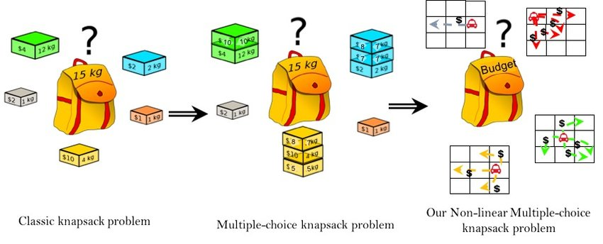

***Types of Knapsack Problems:***

* *0/1 Knapsack Problem:* In this variation, the items are either completely included or not included at all in the knapsack. The items cannot be divided.
* *Fractional Knapsack Problem:* Here, the items can be included in fractions, allowing for a more flexible approach to maximizing the total value.
* *Greedy Approach*: The Fractional Knapsack Problem can be solved using a greedy approach, where items are selected based on their value-to-weight ratio. This involves sorting the items based on this ratio and then adding items to the knapsack in a greedy manner until the capacity is reached.
* *Applications*: The Knapsack Problem has real-world applications in various fields, such as resource allocation, portfolio selection, and test construction.

***Algorithmic Strategy:***

* *Greedy Approach:* For the fractional knapsack, the Greedy Method sorts items based on value-to-weight ratios.

1. Sort the items in decreasing order of value-to-weight ratio.
2. Initialize an empty knapsack.
3. For each item in the sorted list:

a. If adding the item to the knapsack does not exceed the weight limit:

i. Add the item to the knapsack.

ii. Update the weight limit to reflect the addition of the item.

b. Else:

i. Stop iterating.

1. The knapsack now contains the subset of items that maximizes the total value subject to the weight limit.

***Steps for Fractional Knapsack (Greedy Strategy):***

* *Calculate Value-to-Weight Ratios:* For each item, determine the value divided by the weight.
* *Sort Items:* Arrange items in descending order based on value-to-weight ratios.
* *Pack Items*: Start packing items with the highest value-to-weight ratio until the knapsack's capacity is exhausted.

***Importance and Usage:***

Widely used in resource allocation scenarios, such as optimizing profits in business or selecting tasks in project scheduling.

Practical applications in various fields, including finance, logistics, and computer science.